Mongodb for ecommerce given:

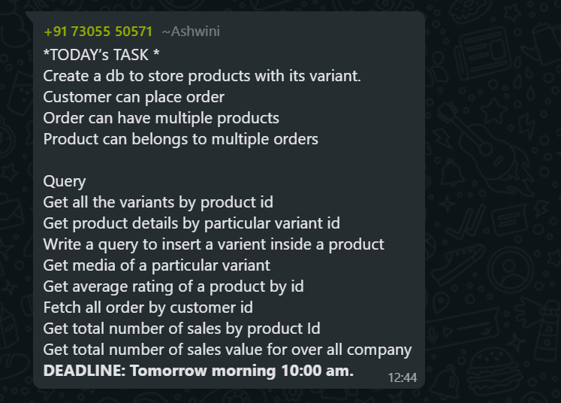

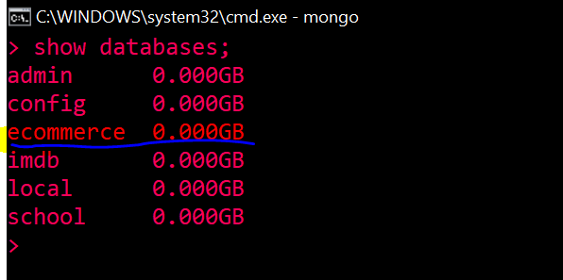

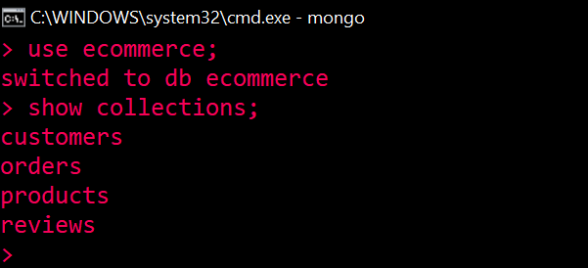

1. Get all the variants by product id

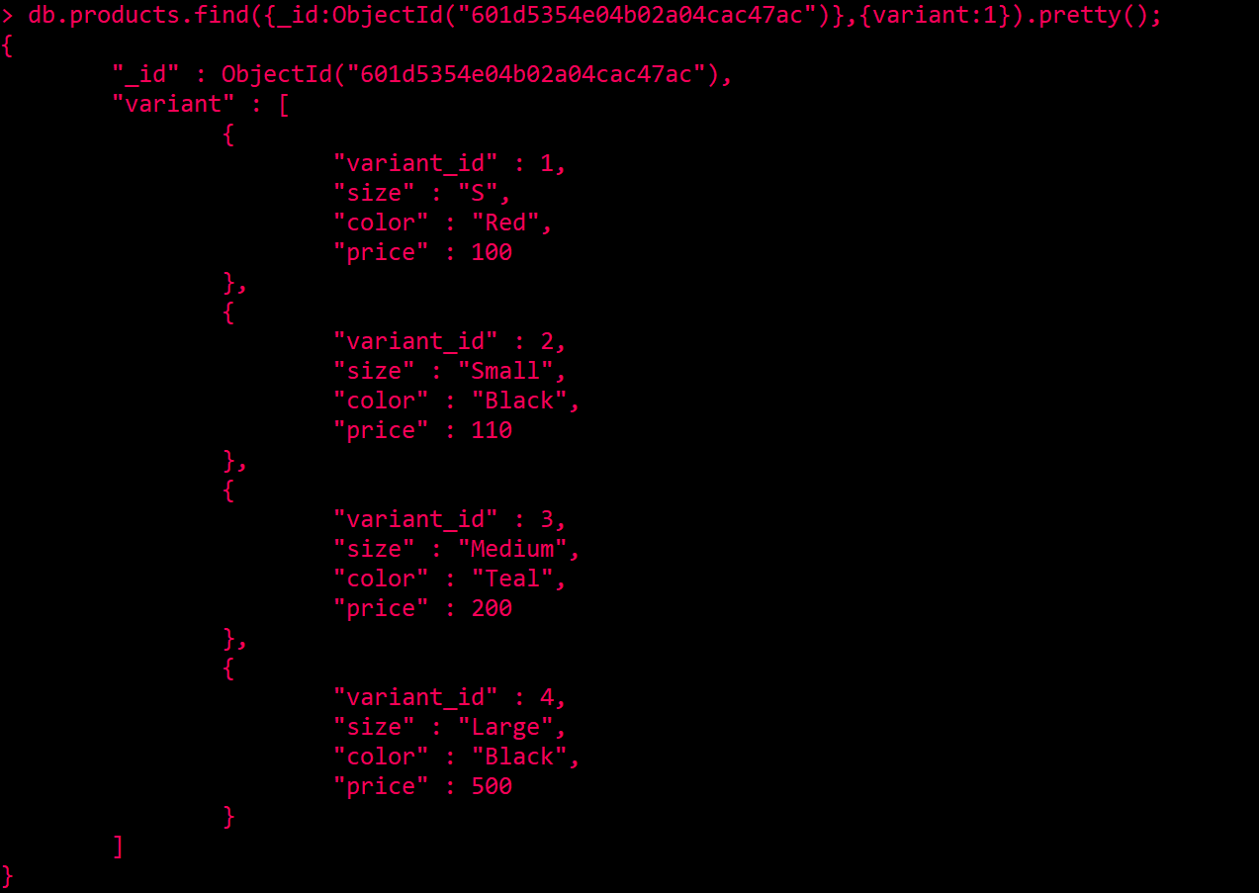

1. Get product details by particular variant id
2. Write a query to insert a variant inside a product

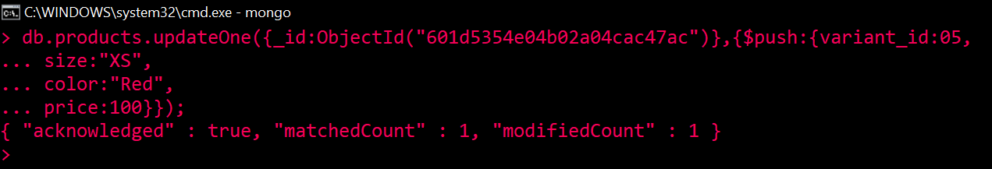

1. Get media of a particular variant
2. Get average rating of a product by id
3. Fetch all order by customer id

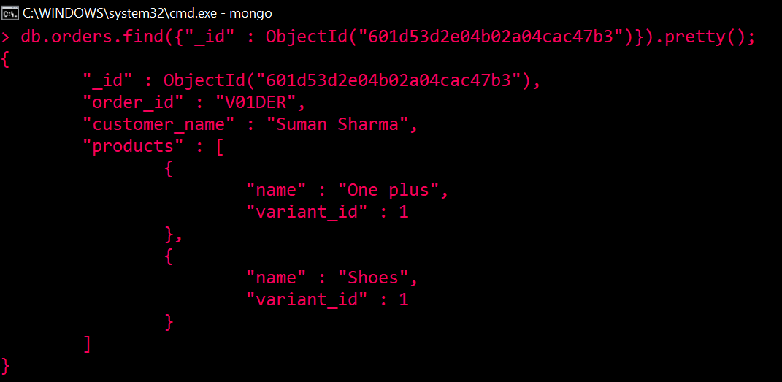

1. Get total number of sales by product Id
2. Get total number of sales values for over-all company